**Problems for January 20**

**Problem 1 - Temperature**

In this problem, you should write a python program that can convert a temperature from fahrenheit to celsius. The program should ask the user for one integer number, (a temperature), calculate the equivalent temperature in celsius, and the print out the result. For example:

Temperature to convert to celsius

**212**

a fahrenheit temp of 212 is 100.0 in celsius.

**Problem 2 - Style**

Show below is a very short python program (TAs, you can copy/paste this and put it into your editor with a larger fort size).

abc = input('What is your ID number?\n')

xz = input('What agency are you a part of?\n')

ptr = input('What is your employment status\n')

print(abc, 'is a member of the agency named', xz, 'with an employment status within said agency with the designation', ptr)

print('If this agency has not provided you with the qualification exam for interpreting the Arabic language, please continue')

However, this program breaks some of the style rules described in the style guide. Fix the code so that it does not break the rules.

**Problem 3 - Sphere**

In this problem, you should write a python program that should ask the user for the width of a sphere. Then, the program should calculate the volume of this sphere and then print it out. For example:

How wide is the sphere?

**77**

The volume of a sphere with diameter 77.0 is 238918.94

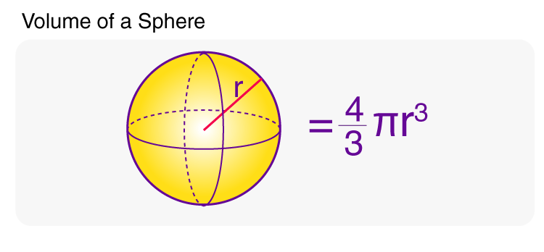

**Solutions**

**Problem 1**

temperature = int(input('Temperature to convert to celsius\n'))

celsius = round((temperature - 32) / 1.8, 2)

print('a fahrenheit temp of', temperature, 'is', celsius, 'in celsius.')

**Problem 2**

* Add a header comment
* Improve variable names
* Lines should not be wider than 100 characters

**Problem 3**

width = float(input('How wide is the sphere?\n'))

radius = width / 2

volume = (4/3) * 3.14 * radius**3

volume = round(volume, 2)

print('The volume of a sphere with diameter', width, 'is', volume)